Join Us… for some

AMISH

Fun & relaxation - Bring a Friend

***May 28 – 31, 2020***

## Ohio Quilts Amish Retreat

Coordinated by **Elaine Fisher**, Ohio Quilts Retreat Chairperson

* Three and ½ days of quilting, eating, learning, sharing and shopping in Amish country with other Ohio Quilts members. Come and meet new friends or bring a friend.
* Class description and supply list will be sent to you upon receipt of paid registration if provided.
* Optional: Bring a carry-in dish or snack to share. Sleeping rooms have mini refrigerators. Bring your own drinks or enjoy our iced tea, coffee and flavored drinks.
* We’ll organize an optional game of “fat quarter bingo” for anyone who would like to play. It takes 15 minutes and you will need three fat quarters per game. You may win more or lose some or all of the ones you bring, by your guaranteed a lot of fun.

**Check-in on Thursday in the classroom will be 9:00 a.m. but you will not be able to check into your rooms until 3:00 p.m. The sewing room is available until 1:00 the day of check out.**

Loading and unloading of vehicles will be done by hotel staff either at the front or rear entrances. Sleeping rooms are located on the second and third floor and are accessible either by elevator or steps.

Hotel staff will also help bring in the sewing equipment for you to set up in the sewing area.

There is also a restaurant located at the rear of the hotel for your convenience.

Hotel Millersburg

35 W. Jackson St., Millersburg Ohio

330-674-1457

# Amish Country

# Spring Retreat

Hotel Millersburg is within walking distance of the downtown area of Millersburg with all of its shops and restaurants.

There are single and double rooms available. Rooms have air conditioning, a mini fridge and television. The classroom has ample table space, ironing boards and irons, a pvc wall to display quilts, wall space to hang flannel and a kitchenette with an adjacent dining room which has table seating. It’s an older facility with all things necessary for a fun quilting experience, deep in the heart of Amish country. Most local businesses, including Amish restaurants, are closed Sundays, our day of arrival (except gas stations).

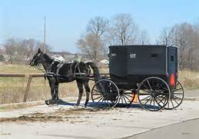

Questions?

Contact:

**Elaine Fisher**

910 Carnation Drive

Wapakoneta, Ohio 45895

(419) 738-7877

befisher@bright.net

Retreat Chairman

**May 28 -31, 2020**

**Hotel Millersburg**

Millersburg, Ohio

35 W. Jackson Street

Millersburg, Ohio

(330) 674-1457



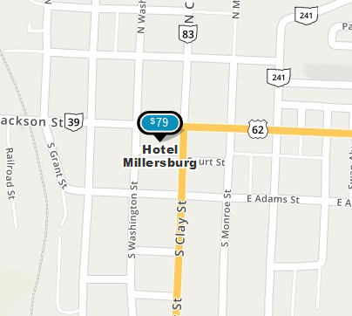

**Fill in registration form**

**Each person attending must fill in a separate registration form and mail to Ohio Quilt c/o Elaine Fisher, 910 Carnation Drive, Wapakoneta, Ohio 45895** no later than May 1, 2020. Forms may be copied. Please mail check and a copy of the registration to: Mary Abbott 2869 Losantiville Avenue, Cincinnati, OH 45213. Limited to the first 40 people with paid

registration.

Make your own Hotel Reservations

Call the Hotel Millersburg to make your room reservation. They will bill you directly. Mention you are with Ohio Quilts!!

**Costs**

Rates listed are per person and include Thursday, Friday and optional Saturday night’s lodging, hot continental breakfasts each morning, evening snacks, and a casual dinner Sunday evening. Tables for sewing and cutting and access to irons and ironing board in the sewing room is included. Goody bags with local maps, coupons, special offers and more surprises will be provided. Confirmation and a receipt will be sent to you upon receiving your paid registration. All profits from this retreat are used to provide educational activities, speakers, workshops and educational grants for Ohio Quilts!!

**Cancellations before May 1, 2020 are subject to a $5 service fee. No refunds after May 1, 2020.**

**REGISTRATION DEADLINE:**

**May 1, 2020**

**From East:** Take I-71 south to New Philadelphia; go south on S Broadway St/OH-800/OH-416 toward Allen Ln; Merge onto US-250 W toward Wooster; merge onto I-77 N/US-250 W via the exit on the left toward Cleveland; Take the OH-39 exit, EXIT 83, toward Dover/Sugarcreek/OH-211; turn left onto Ohio & Erie Canalway/N Tuscarawas Ave/OH-39. Continue to follow OH-39; Hotel Millersburg, 35 W JACKSON ST is on the left.

**From West:** Take Route 30 to Mansfield; go east on Park Ave/OH-430 toward S Diamond St/OH-13. Continue to follow OH-430; Turn right onto Lucas Rd/OH-39. Continue to follow OH-39 into Millersburg; Hotel Millersburg, 35 W JACKSON ST is on the right.

**From North:** Take US 250 to Route 302; follow to Route 83 in Millersburg; turn right onto Amish Country Byway/W Jackson St/OH-39; Hotel Millersburg, 35 W JACKSON ST is on the left.

**From South:** Take Route 23 North to I-670 E toward Airport; go Northeast Fwy/US-62 E toward Cleveland to I-270 North; exit on US Route 161 E to US Route 62 E; Turn left onto Amish Country Byway/State Route 83/US-62 E/OH-83. Continue to follow Amish Country Byway/US-62 E/OH-83 to US Route 39; Hotel Millersburg, 35 W JACKSON ST is on the left.

# Directions

## How to register

Registration Form

|  |  |  |  |  |  |
| --- | --- | --- | --- | --- | --- |
| Sign up for: | |  |  |  | |
| ❒ | I am a 2020 Ohio Quilts Member |  |  |  | |
| ❒ | I am enclosing my 2020 dues. $15.00 is enclosed with my registration |  |  |  | |
| ❒ | Retreat Registration | $20 |  |  | |
| ❒ | 2 nights | $ |  | Thurs & Fri | |
| ❒ | 3 nights | $ |  |  | |
| ❒ | Private Room per night | $79 |  |  | |
| ❒ | Double Room per night | $65 |  |  | |
| ❒ |  |  |  |  | |
| ❒ | Assign a roommate to me |  |  |  | |
|  | OR |  |  |  | |
| ❒ | Rooming with:____________________________ | | | | |
|  | | | | | |
| Registrant Name | | | | | |
| Registrant Address | | | | | |
|  | | | | | |
|  | | | | | |
| Registrant Home Phone | | | | | |
| Registrant Cell Phone | | | | | |
| Registrant E-mail | | | | | |
| Total Enclosed $ | | | | |
| Please mail check and a copy of form to:  Mary Abbott  2869 Losantiville Avenue  Cincinnati, OH 45213 | | | | |

Z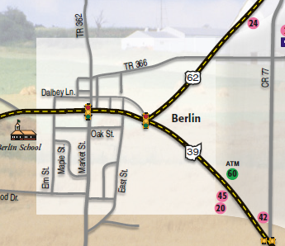inck’s

Inn